**Submitted by: Submitted to:**

**NAME: Rahul Gusain Hitesh Kumar Sharma**

**SAP: 500084143**

**ROLL NO.: R214220900**

**BATCH: 1 DevOps**

# Build and Release Management

**LAB EXERCISE 4**

**Aim:** Install and Manage Maven Plugin using Eclipse

Install Site Plugin and use “mvn site” command and goal for generating documents for Maven Project using Eclipse.

**Step 1:-** First create a Maven project and provide Group id, Artifact id and Name.

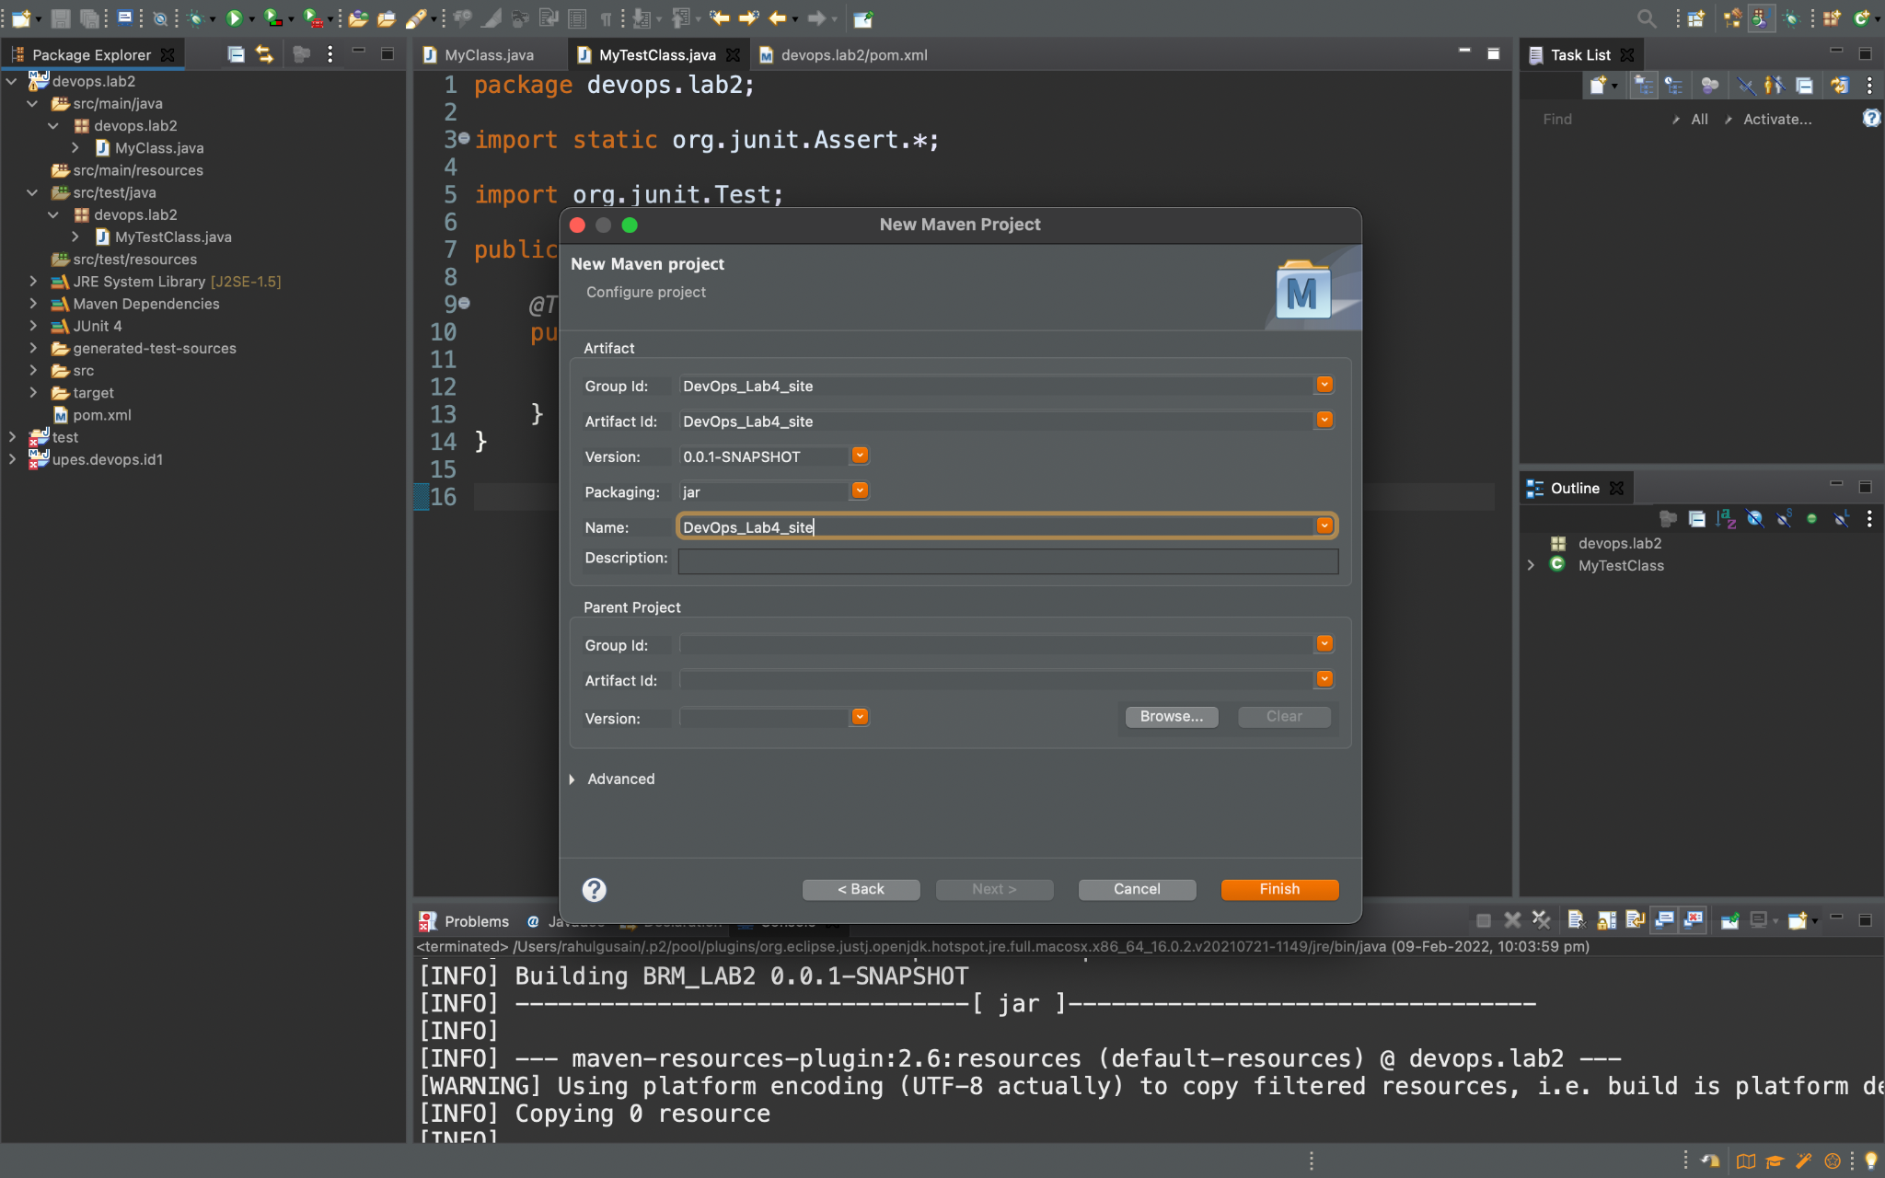

**Step 2:-** Now create a package inside it.

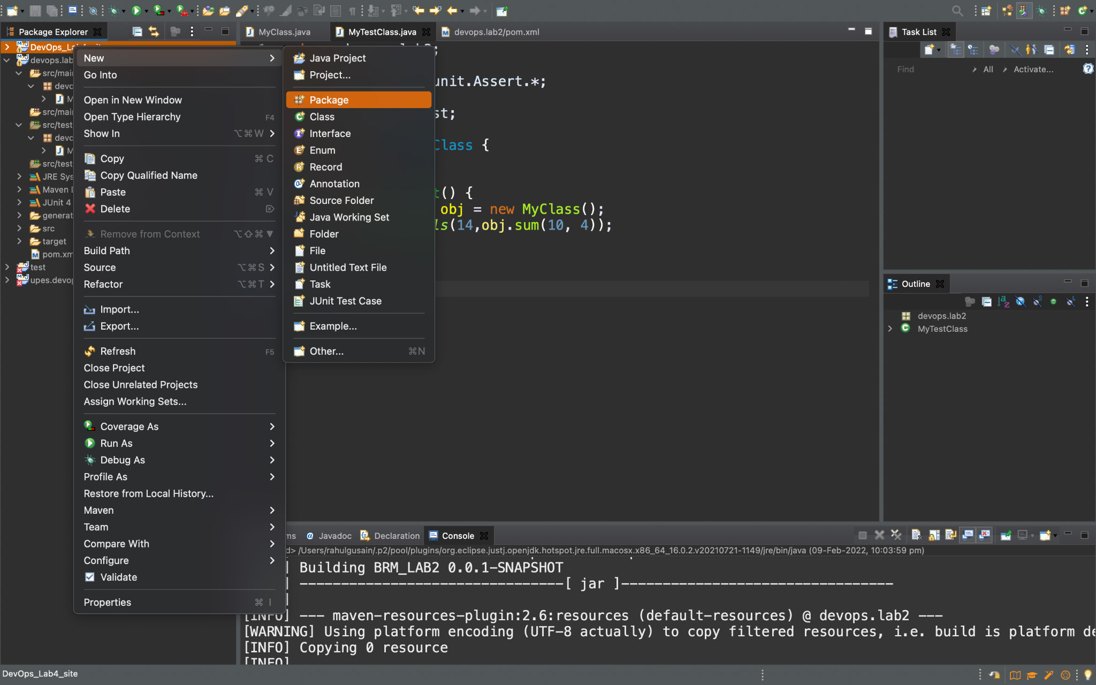

**Step 3:-** Now In that package create a class.

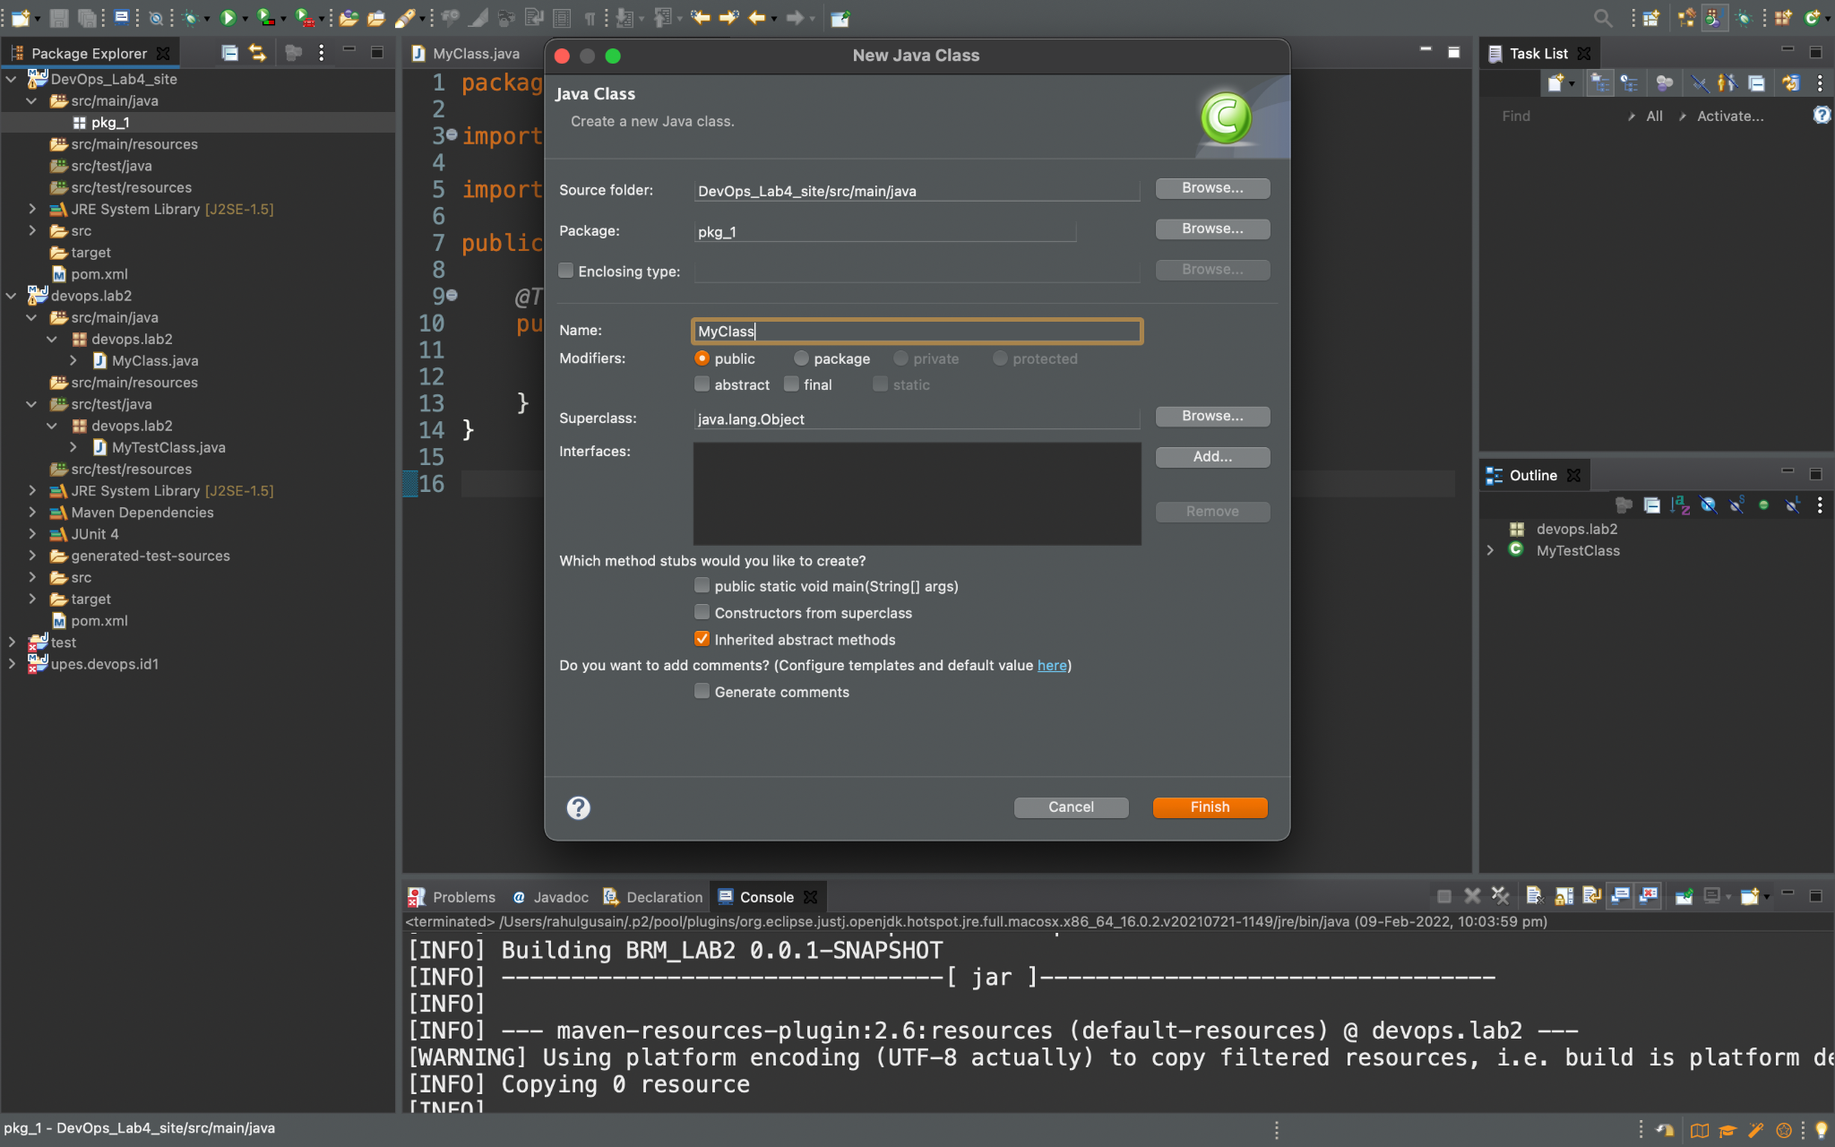

**Step 4:-** Now create a method of Average in it.

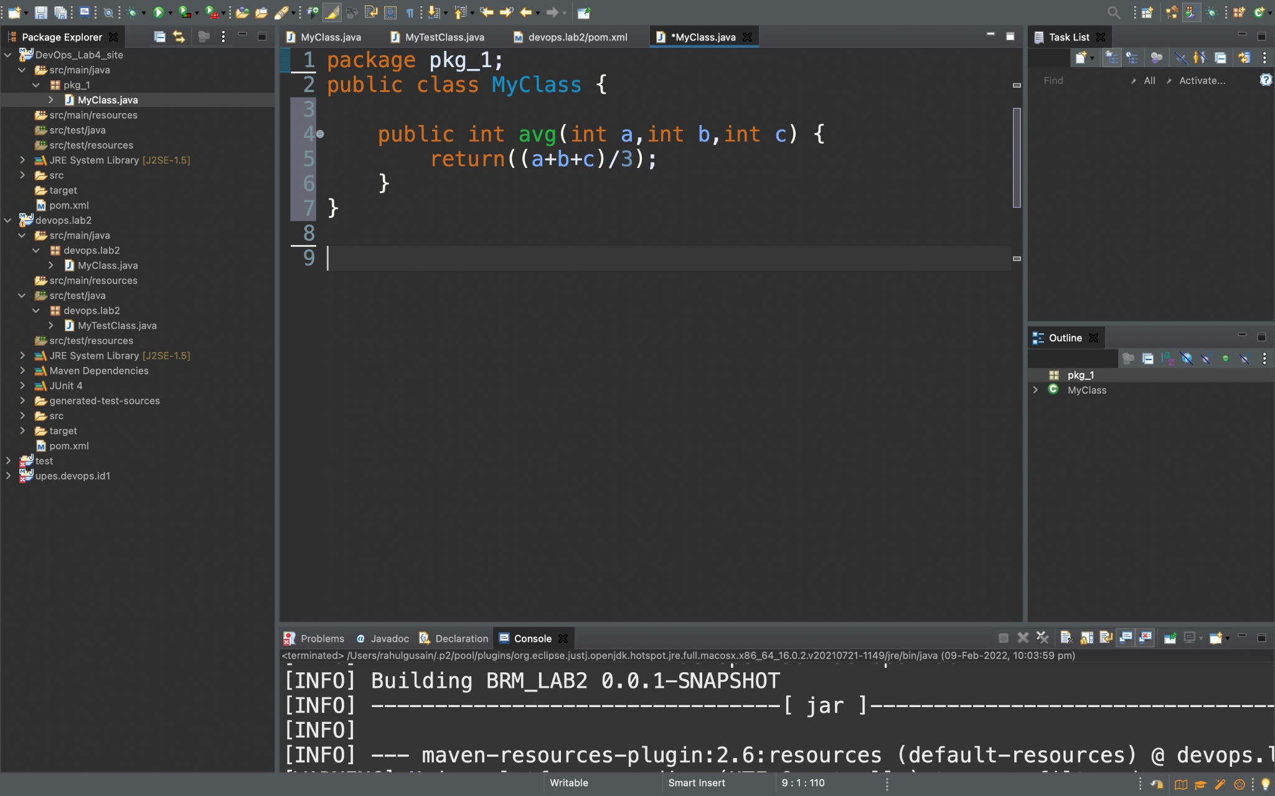

**Code :-**

**package** pkg_1;

**public** **class** MyClass {

**public** **int** avg(**int** a,**int** b,**int** c) {

**return**((a+b+c)/3);

}

}

**Step5:-** Now create a new class under the package and call the class having code by creating an object of it.

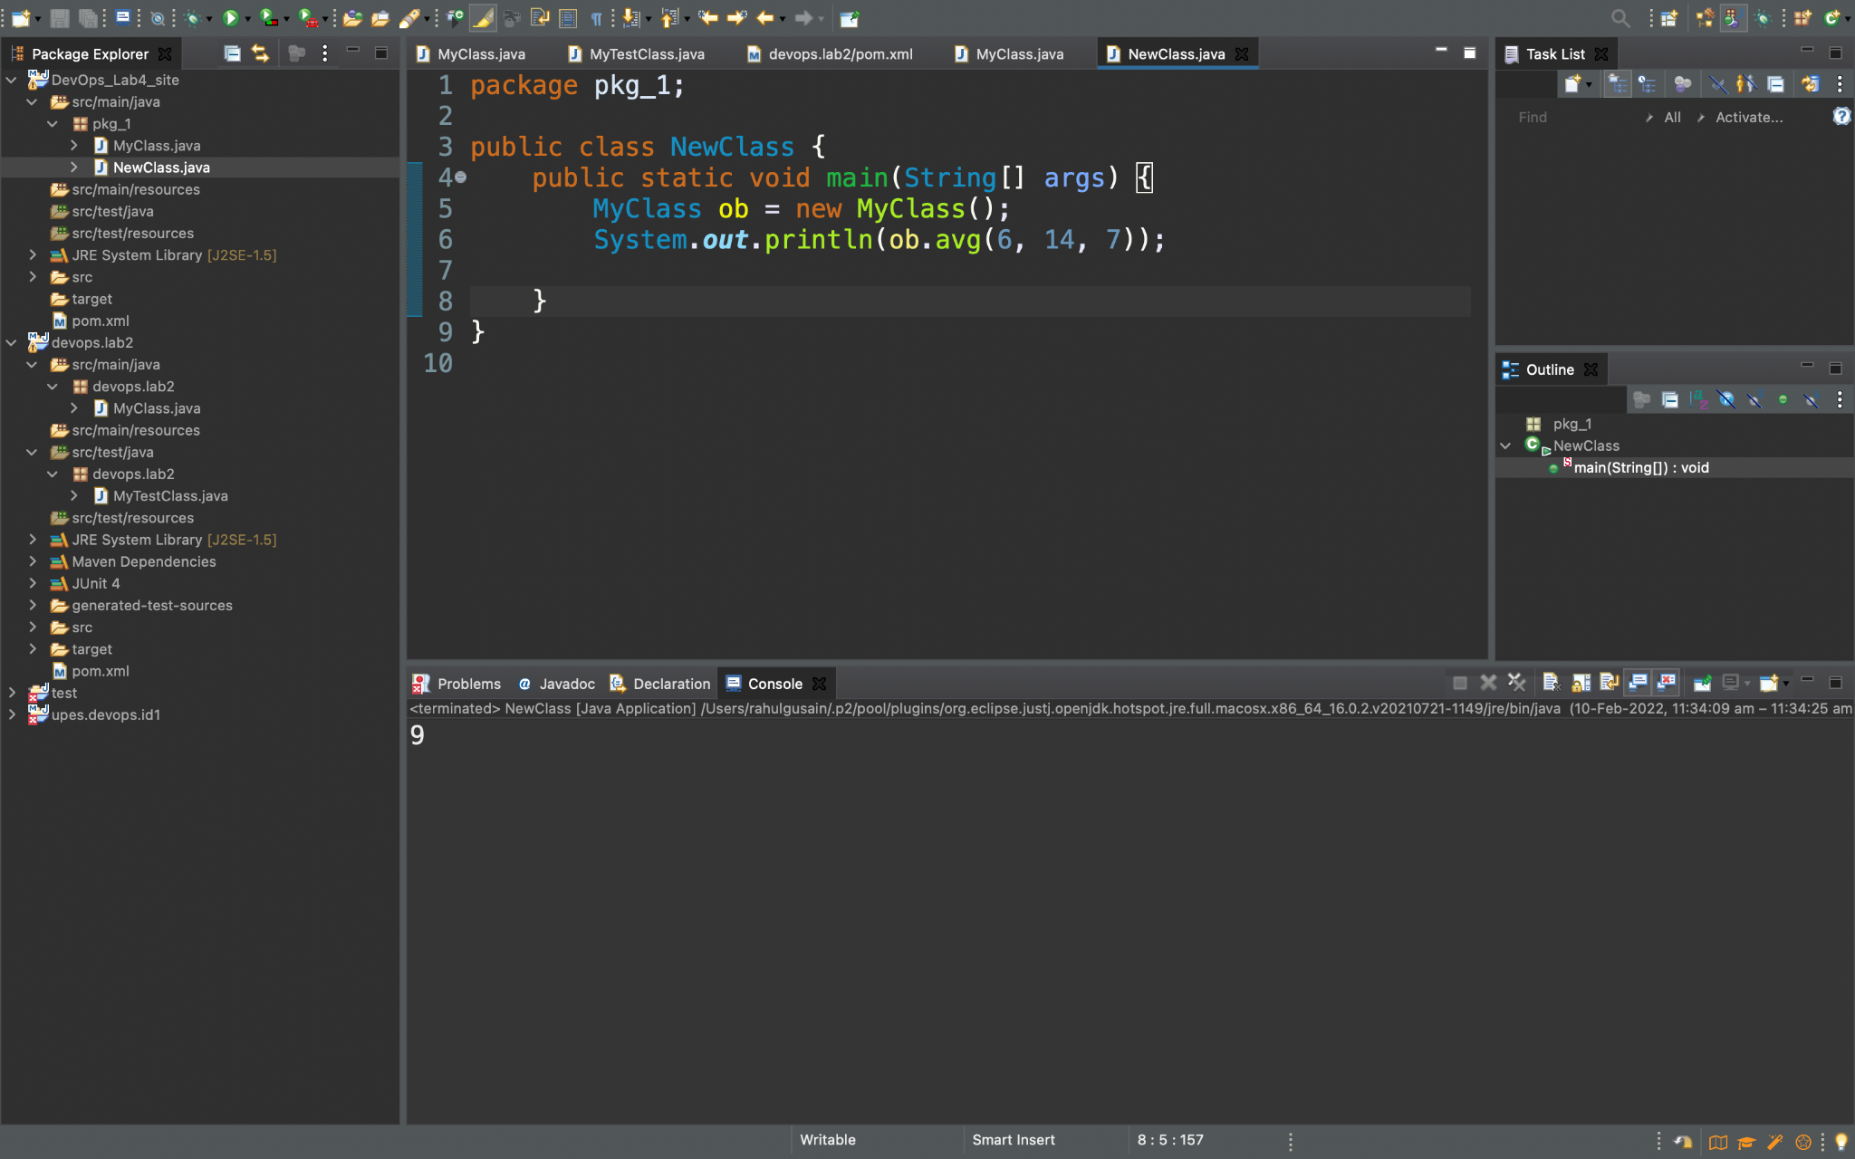

**Step 6:-** Now right-click on the project and then click on new and then on Junit Test Case.

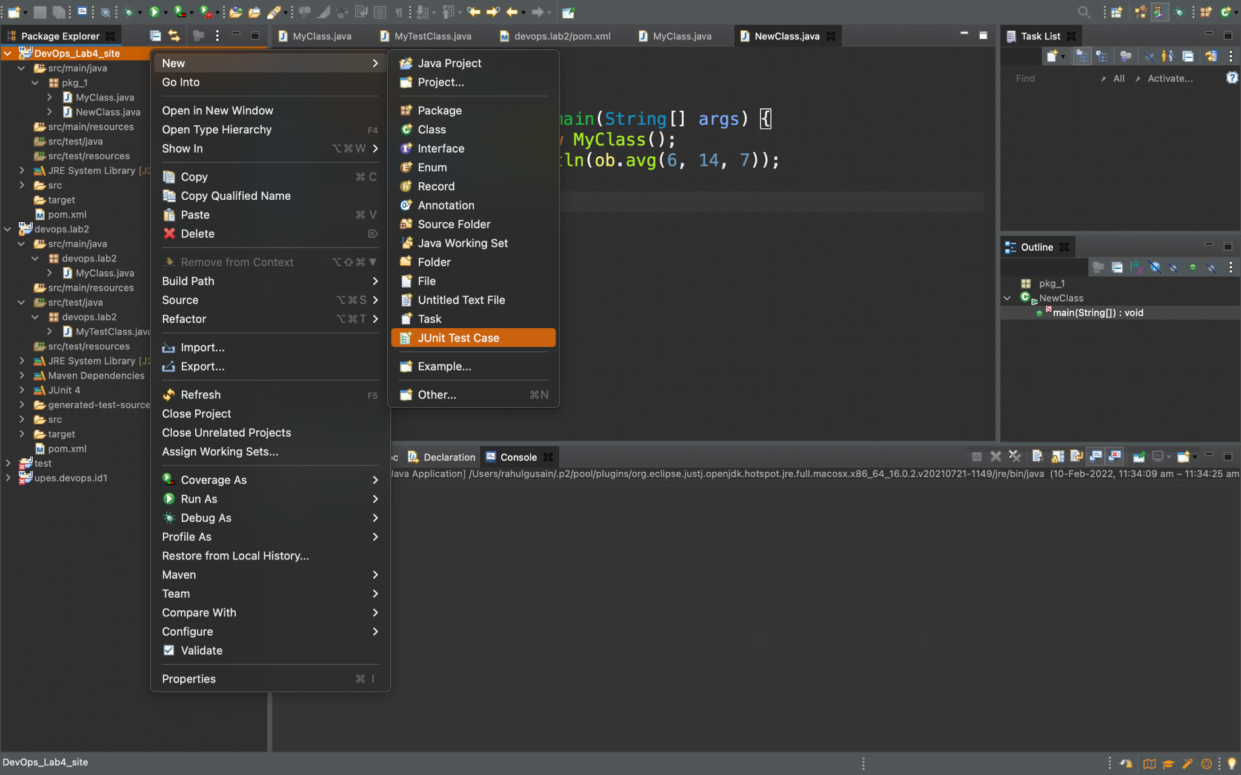

**Step 7:-** Now create a test Class and finish.

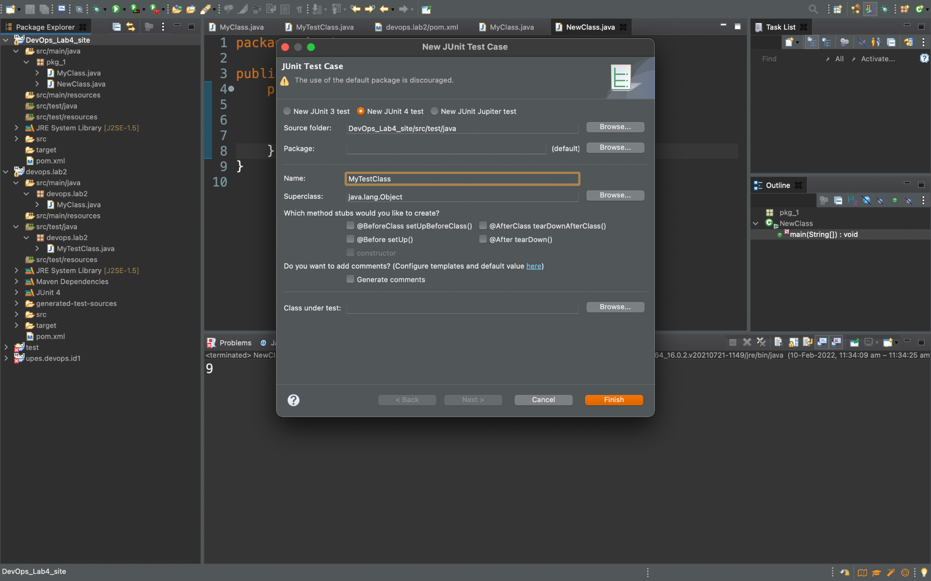

**Step 8:-** Now we can see an already written code.

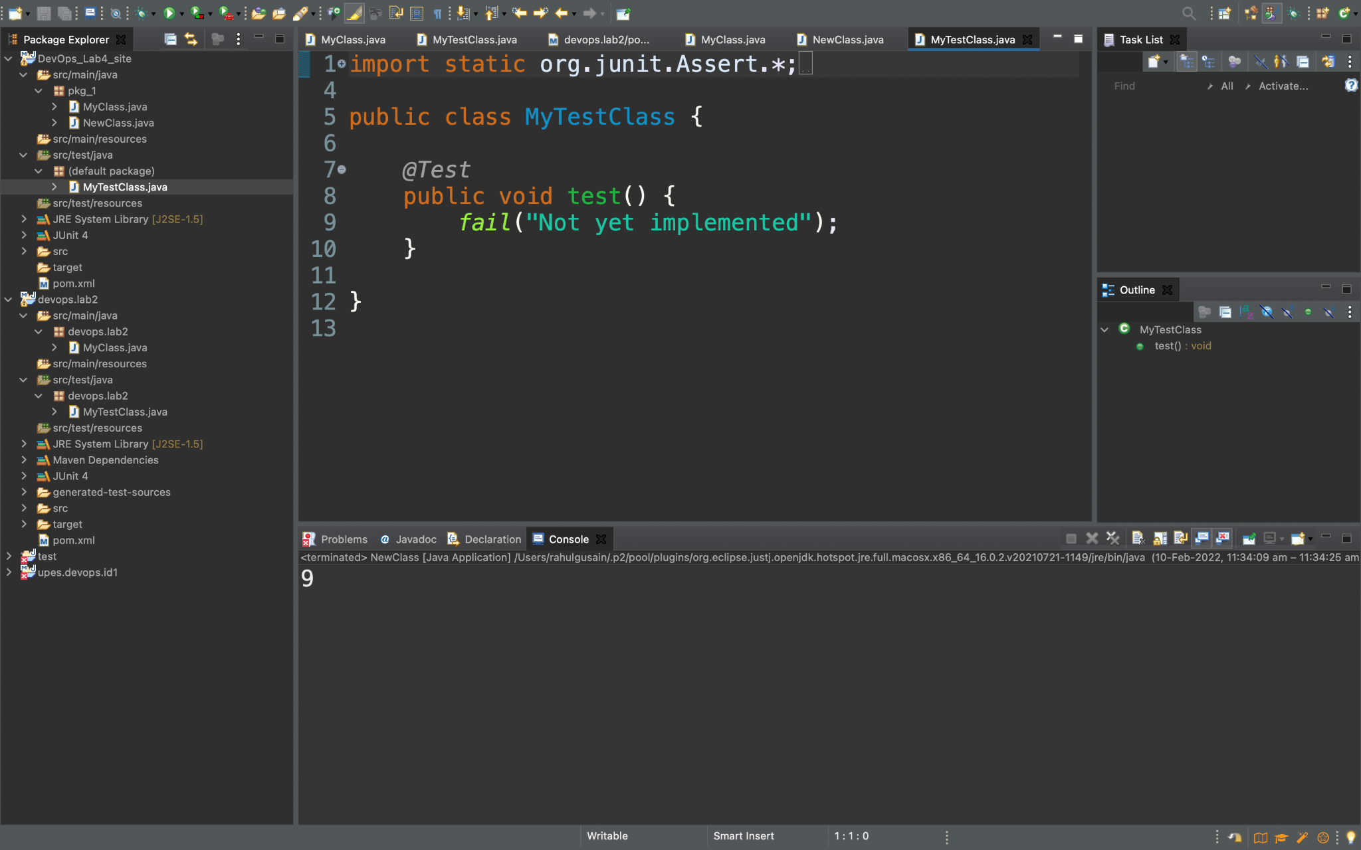

We will cut this fail function and write our assert Equal function for the testing.

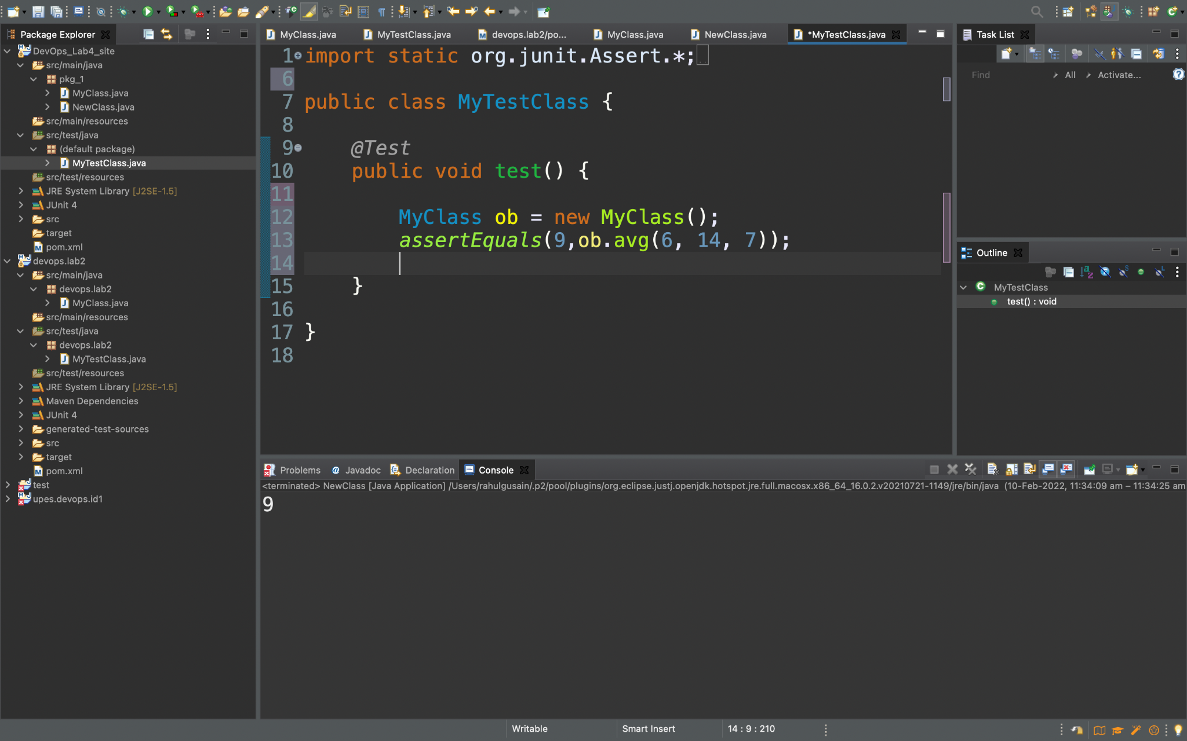

**Step 9:-** Now we will run the Junit test case and we can see that it runs successfully with no Errors and Failures.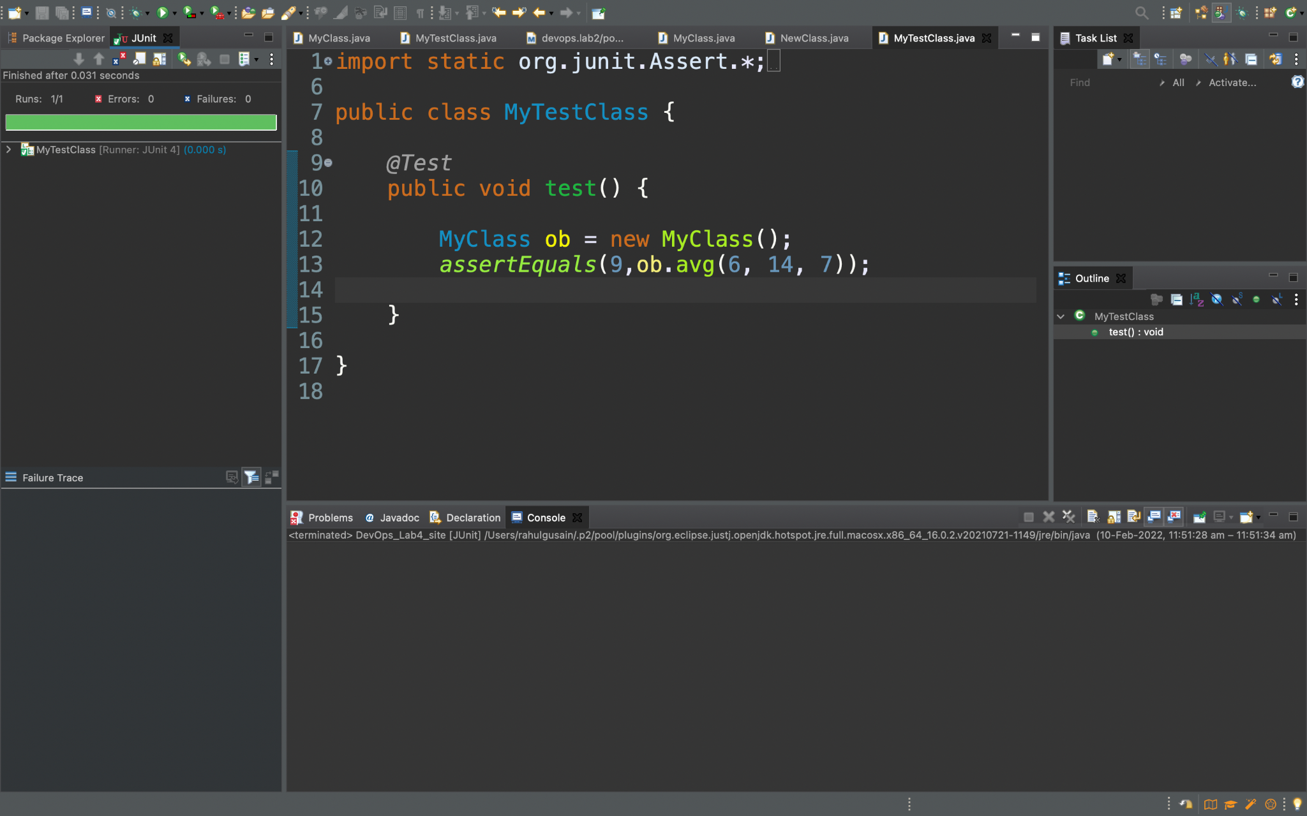

The green line that is visible on the top left side of the screen represents that this test case is running successfully without any error

**Step 10 :-** Now in our Pom.XML file first we will add this dependency.

<properties>

<maven.compiler.source>1.8</maven.compiler.source>

<maven.compiler.target>1.8</maven.compiler.target>

</properties>

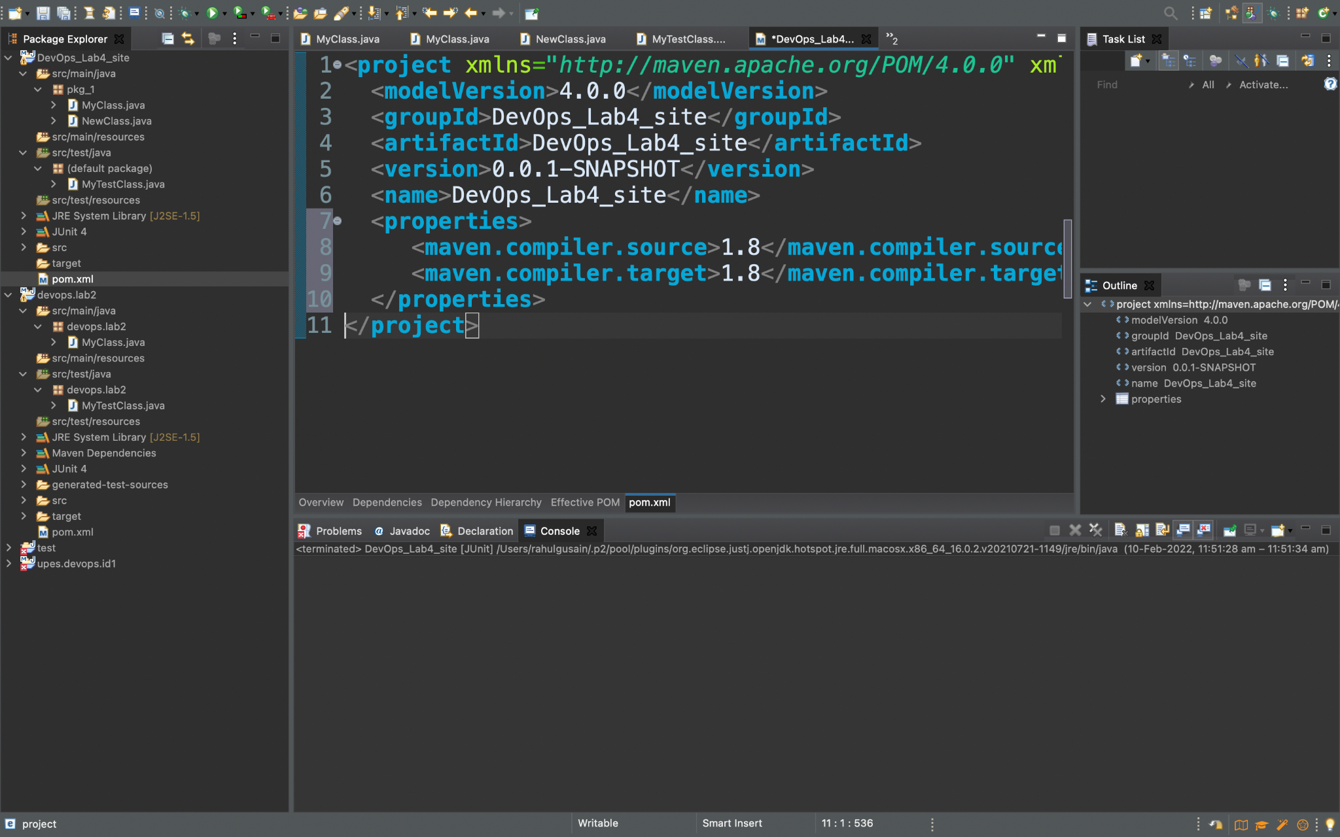

**Step 11:-** Now we will do the Maven build and set goal as install.

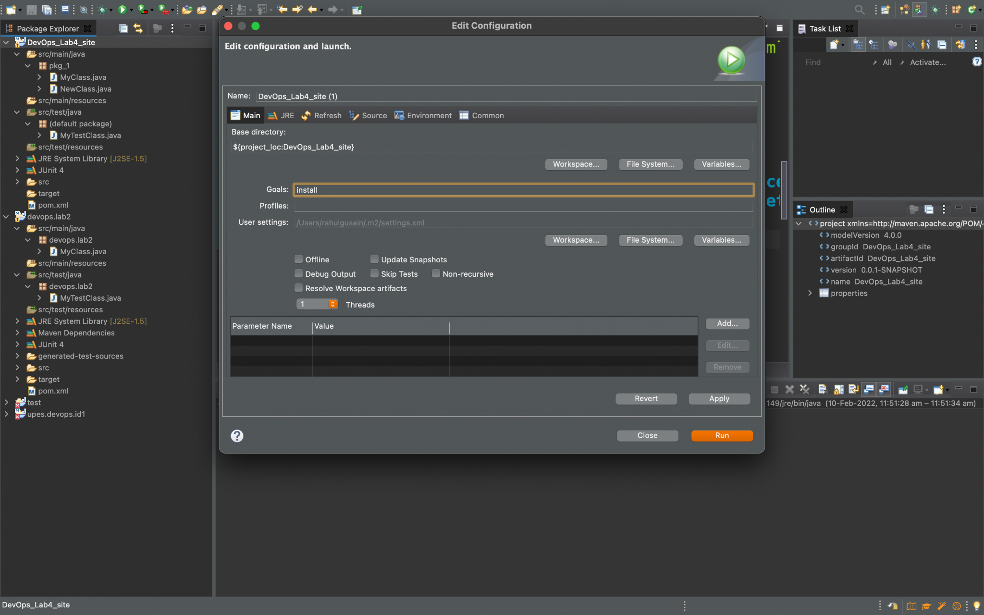

We can check that the build is successful.

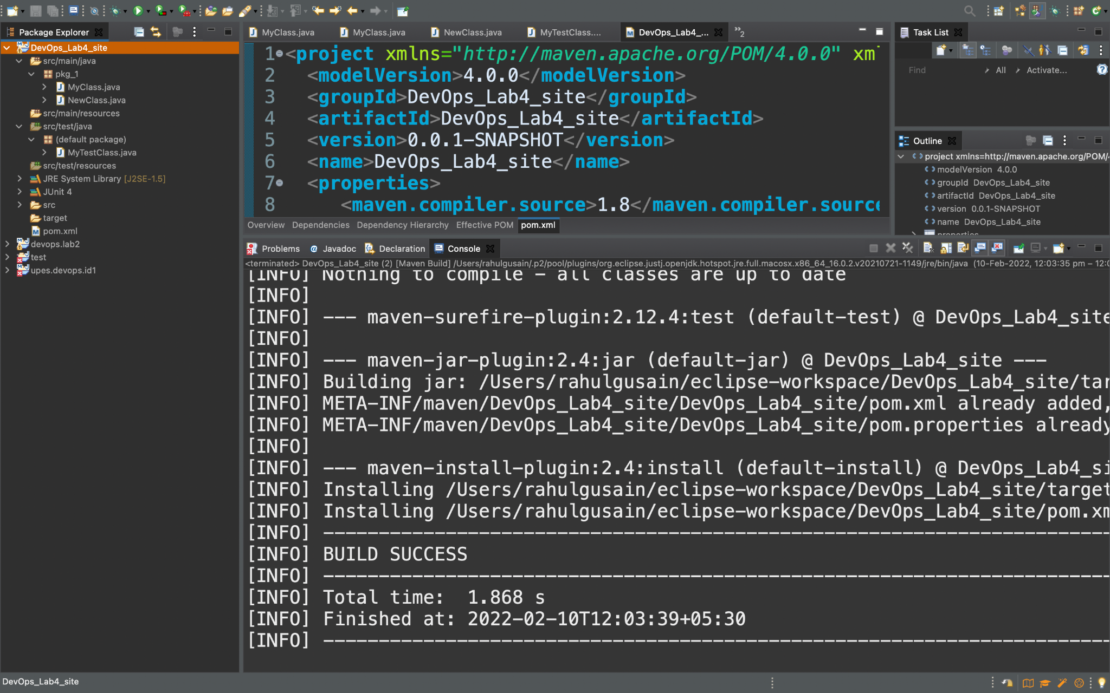

**Step 12 :-** Now will add a new dependency in the pom.xml file.

<dependencies>

<dependency>

<groupId>junit</groupId>

<artifactId>junit</artifactId>

<version>4.12</version>

<scope>test</scope>

</dependency>

</dependencies>

<reporting>

<plugins>

<plugin>

<groupId>org.apache.maven.plugins</groupId>

<artifactId>maven-project-info-reports-plugin</artifactId>

<version>3.0.0</version>

</plugin>

</plugins>

</reporting>

<build>

<plugins>

<plugin>

<groupId>org.apache.maven.plugins</groupId>

<artifactId>maven-site-plugin</artifactId>

<version>3.7.1</version>

</plugin>

</plugins>

</build>

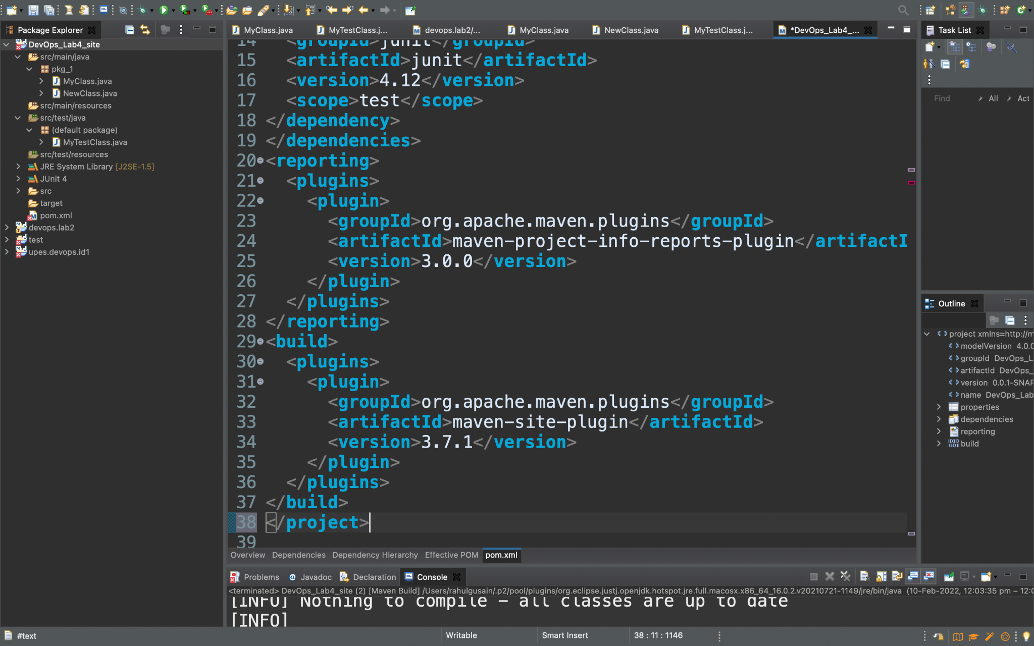

**Step 13 :-** Now again do maven build but this time set goal as “site”.

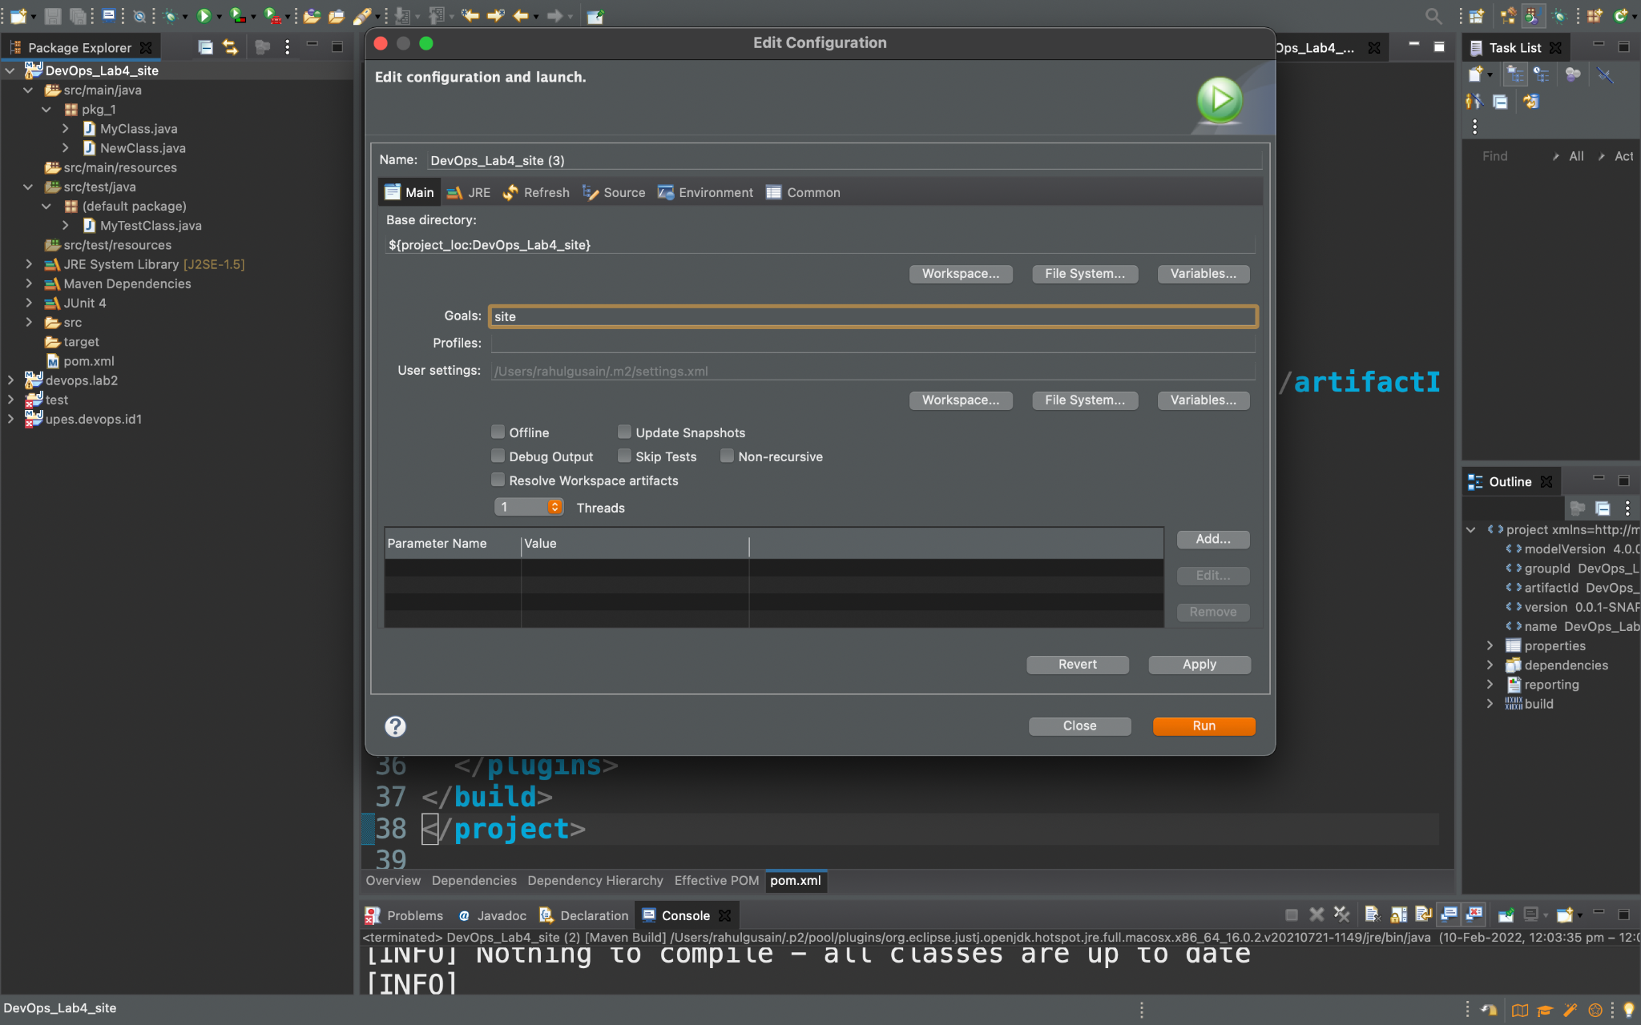

We can check that the build is successful.

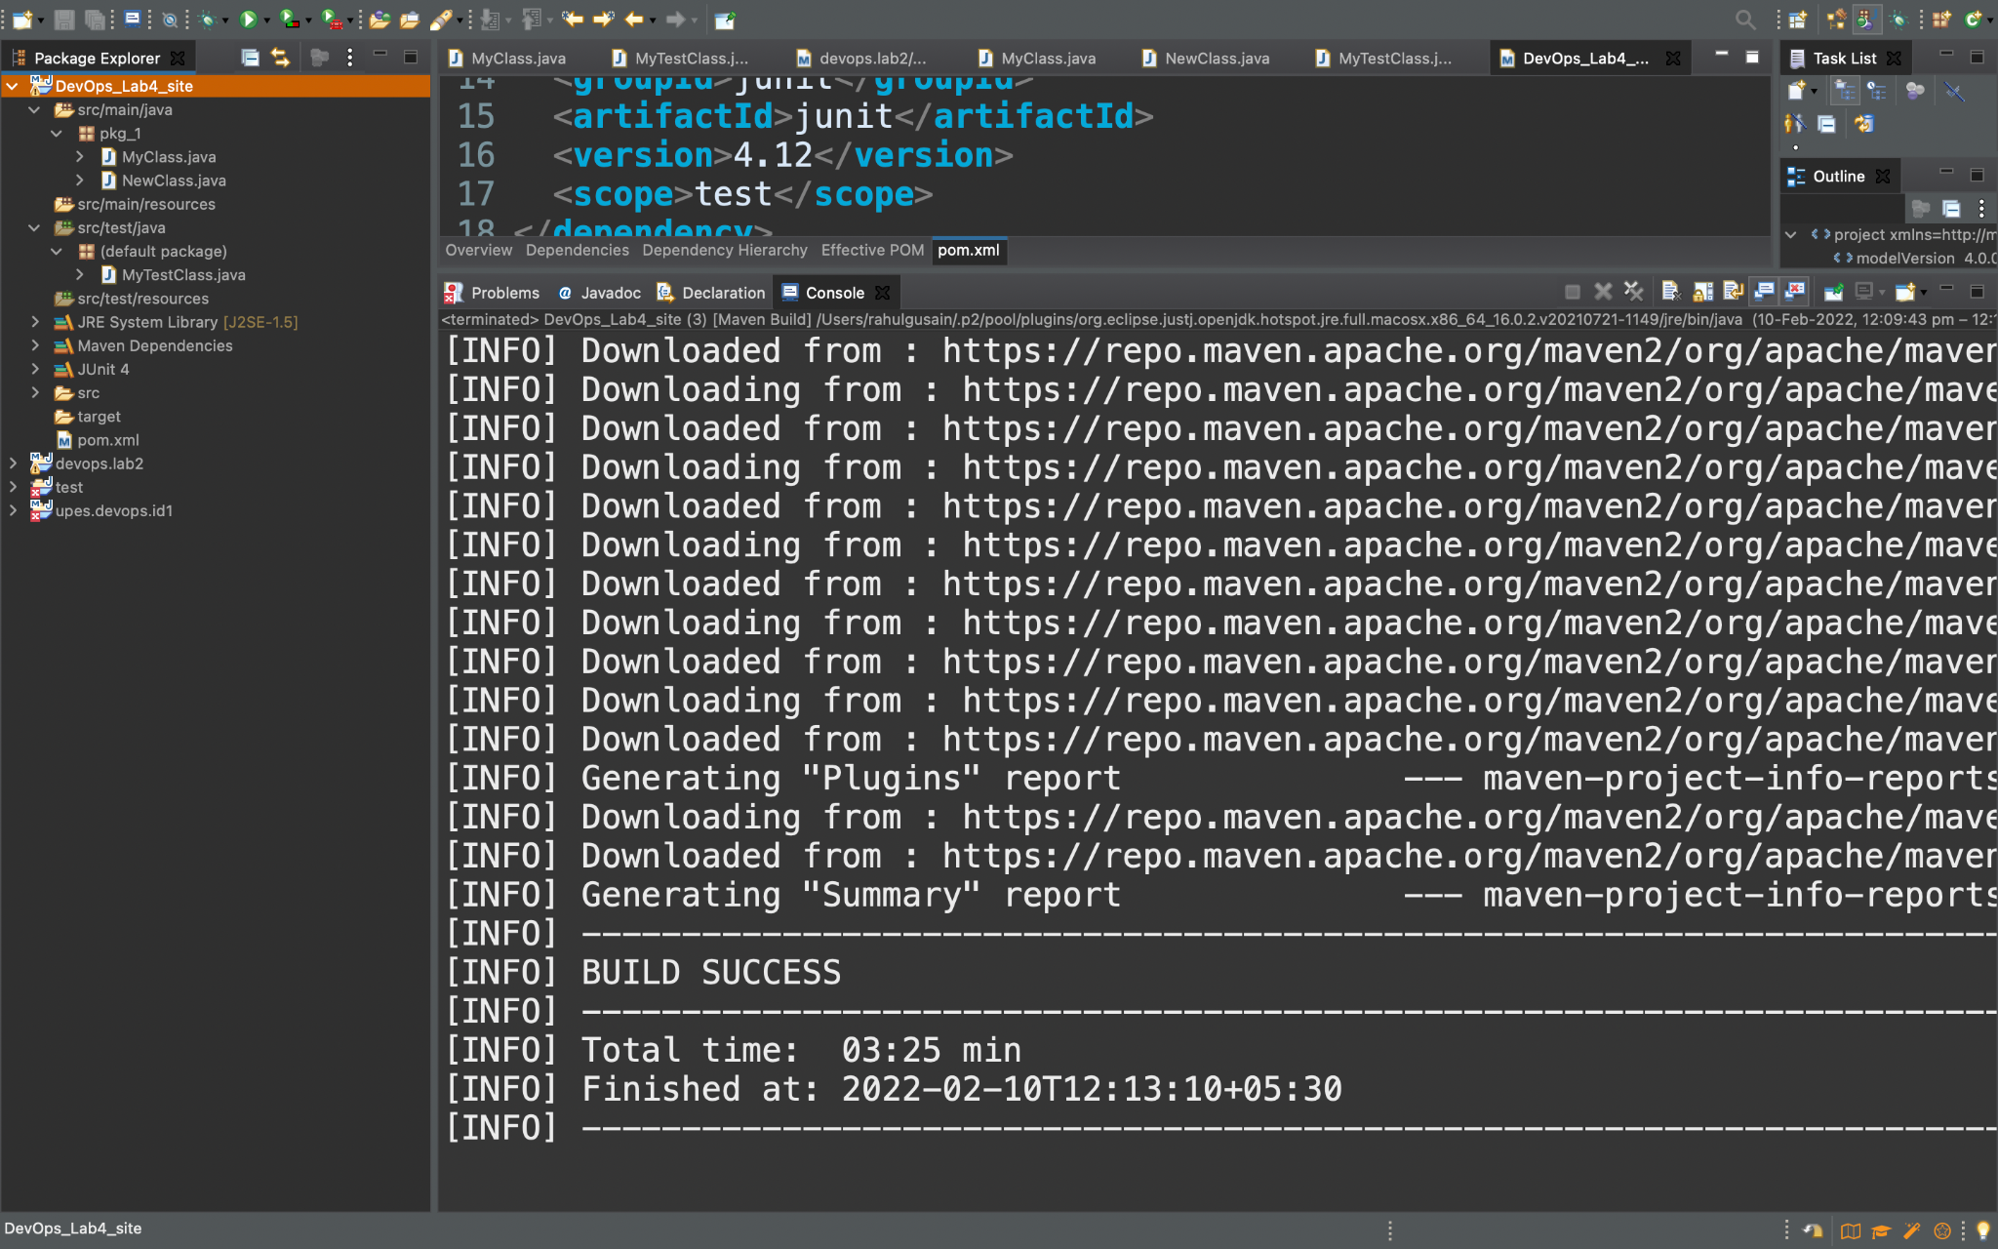

**Step 14 :-** Now Go to the Drive and look for the site folder which is been created.

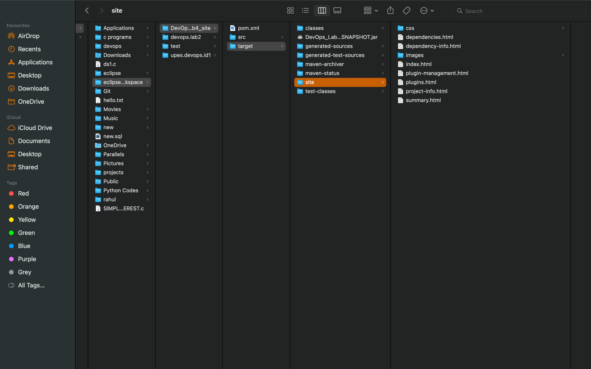

Here we see that it Automatically downloaded sites for us where we can see different things such as Plugins, Dependency used, index etc.

